Carrier Air Cooled chiller cheatsheet
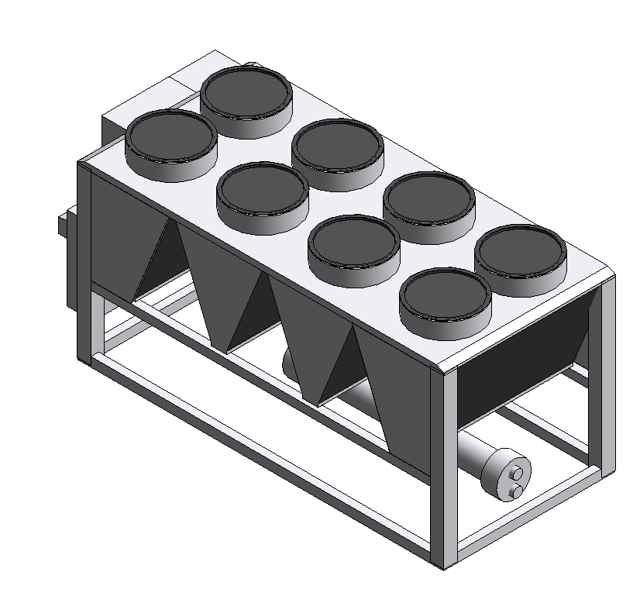

Quick how-to guide for sales on how to operate carrier 30XV families

Carrier has provided a new inventory of Autodesk Revit 2016 files (families) for certain product lines. The aim was to improve the user experience and aid in reducing the total number of files for the user to select.

To achieve this goal, some families needed to be reworked to be able to contain as many similar products as possible into one family file. The 30XV was one of those families. Instead of having one file for every configuration, all configurations now reside in one file.

The geometry is simplified as to not cause too much strain on large project files. Providing fabrication-level geometry is generally frowned upon for products that do not need to show every detail of the unit. Graphically, only the overall size of the unit, clearances, control options, and pass options are included. Most other performance data is user input due to the complexities of the product and how certain options interact with others.

Please see the following pages for more information on how the end user interacts with these families in the Revit software.

When a user first loads a packaged chiller into their project file, they are met with a screen asking them to select a type. All sizes for the chiller are listed along with additional dimensional and other data relevant for each size. Users may filter these columns by values they desire, or simply select the tonnage they require. If users are using the configuration portal, this process happens there with the extra benefit of filling out the model number more thoroughly.

Once the family has been loaded into the project, there is little interaction needed on their part to finish
the unit they have selected.
As an example for the 30XV, pass options are selected on a user input value. In the properties menu, under the Construction tab, there is a parameter for “Evaporator Option”. This is a number value with three options listed beneath it. A value of “2” gives the user a Single Pass Evaporator. A value of “3” gives the user the Brine Evaporator. Any value other than 2 or 3 gives the user the Standard Two Pass Evaporator.

All other user input values are for showing clearances or performance or electrical values.

