Carrier small RTU cheatsheet
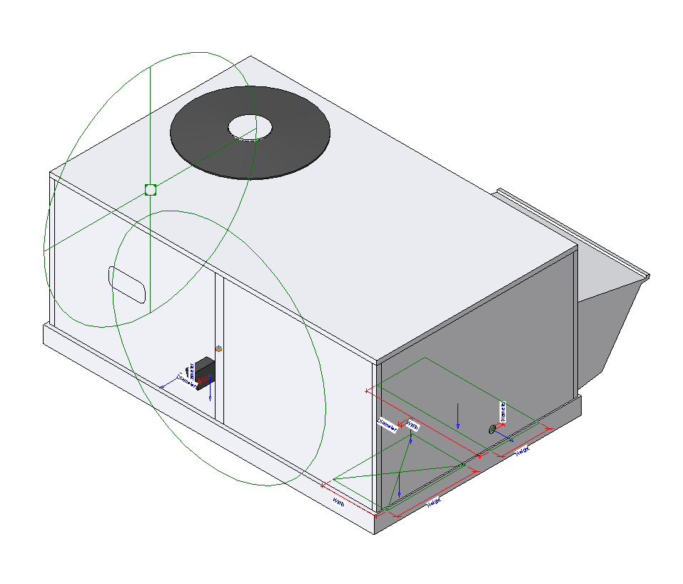

Quick how-to guide for sales on how to operate carrier RTU families
Carrier Revit families, provided by BIMSmith, are authored in Revit version 2016. Revit software is not backwards compatible, so the families cannot be used in previous software versions (2015 and below) unless exported to other CAD software. The families can be used in all software versions above 2016.
Carrier Revit families come with text files named similarly to the .rfa Revit file, known as type catalogs, that house all of the available tonnage options. When a RTU is loaded into a Revit project, users will be given that list of tonnage options to choose from.
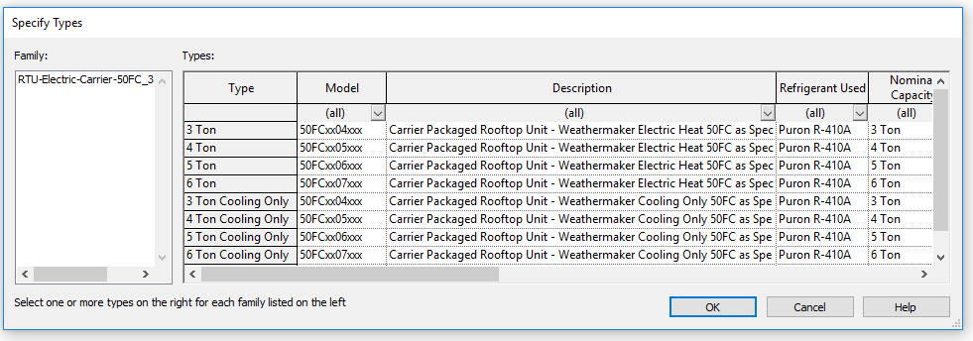
Users may select as many of the options as they want to bring in. If users want to bring in additional tonnage options after the RTU has already been loaded, they may find the product in the Project Browser, right click on the product, and click “Reload”.

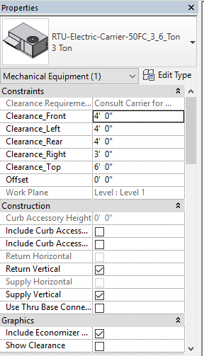
Certain RTUs have specific types for Vertical and Horizontal duct connections. For the RTUs that do not have specific types for Vertical and Horizontal duct connections, there are simple Yes/No checkbox options for deciding which direction the airflow is.
When in a project, clicking on the RTU will display a Properties window that shows users instance parameters that can be unique between identical tonnage sizes. These units can have Supply Air Vertical or Horizontal and Return Air Vertical or Horizontal. The connections automatically rotate and resize themselves to the appropriate dimensions and locations.
Clearance dimensions can be set to the recommended requirements for their project needs. Users are guided to contact Carrier to consult on specifics.
Clicking on ‘Use Thru Base Connections’ will visually turn on the locations, in plan view and 3D views, for all required utilities.
The Economizer hood can be turned on and off with the checkbox under the Graphics tab.
Clearances can be turned on and off with the checkbox under the Graphics tab.
The Curb accessory can be turned on and off with the checkboxes under the Construction tab. Both sizes, 14” and 24”, are available.

